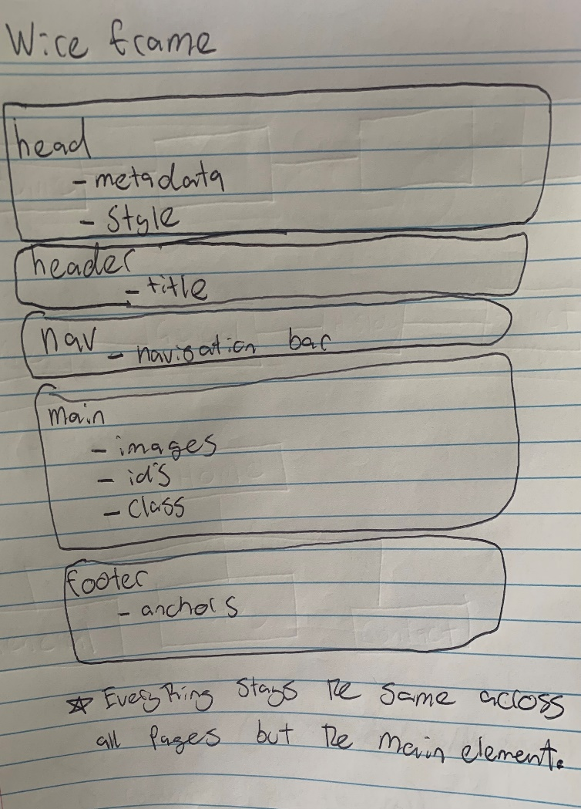**Site Map and Wireframe:**

**References:**

Index.html: Both images were taken by me as well as the icon image

General.html:

Alpha Paw. (2022). *The 3 Types Of Dachshunds: Do You Know Them All?* [online] Available at: <https://www.alphapaw.com/blog/the-3-types-of-dachshunds/>

[Accessed 29 Oct. 2022].

‌The Independent. (2015). *Horrendously obese dachshund makes amazing recovery*. [online] Available at: <https://www.independent.co.uk/news/world/americas/dennis-the-dog-obese-dachshund-loses-75-of-his-bodyweight-10103500.html>

[Accessed 29 Oct. 2022].

History.html:

Dec 03, D.F., Dec 03, 2020 | 4 M. and Minutes, 2020 | 4 (n.d.). *Dachshund History: The Badger Dog’s Fascinating Past*. [online] American Kennel Club. Available at: <https://www.akc.org/expert-advice/dog-breeds/dachshund-history-badger-dog-breed/>.

Hampdach Dachshunds. (n.d.). *Hampdach Dachshunds*. [online] Available at: <https://www.hampdach-dachshunds.co.uk/>.

‌**Validation:**

‌